1. Applicant Information
- Full Name: Robert Miller
- Date of Birth: March 12, 1988
- Address: 2458 Maple Street, Austin, TX 78745
- Phone Number: (512) 555-7834
- Email Address: john.miller@email.com
2. Vehicle Information
- Vehicle Type: Collector / Classic Vehicle
- Year: 1967
- Make: Ford
- Model: Mustang Fastback
- VIN: 7F02C123456
- Current Market Value: $45,000
- Condition: Excellent / Restored

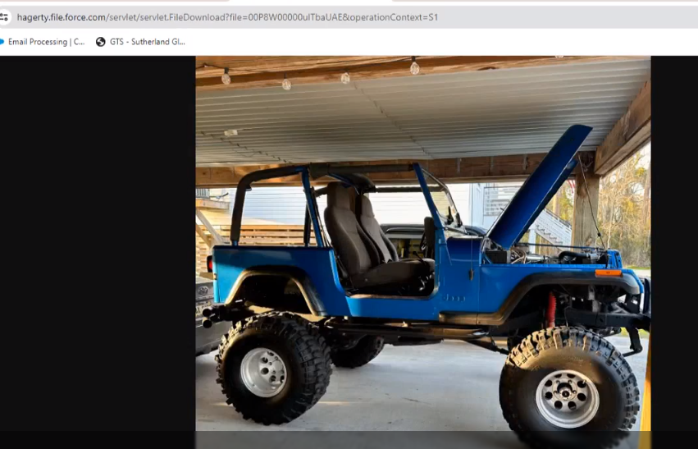
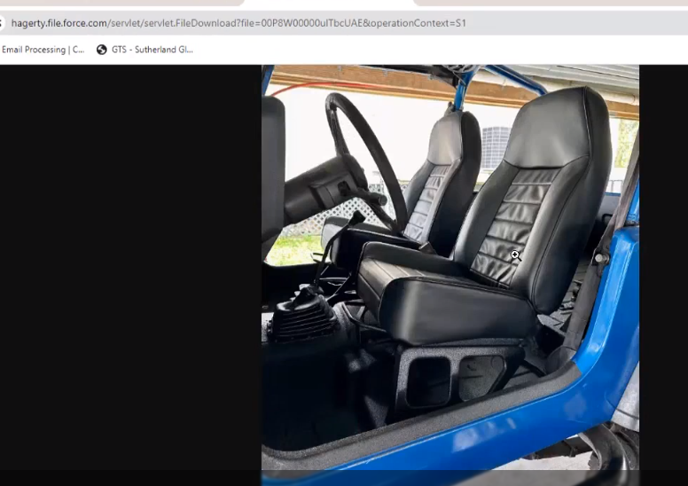
3. Vehicle Usage & Storage
- Usage Type: Pleasure use only (no daily commuting)
- Estimated Annual Mileage: 2,500 miles
- Storage Type: Fully enclosed private garage
- Anti-Theft Devices: Steering wheel lock & garage security system
4. Ownership & History
- Ownership Duration: 6 years
- Restoration Details: Frame-off restoration completed in 2021
- Modifications: Original engine restored; no performance modifications
5. Driver Information
- Primary Driver: John Miller
- Years of Driving Experience: 15 years
- Accidents/Violations (last 5 years): None
6. Coverage Requested
- Coverage Type: Agreed Value Coverage
- Requested Agreed Value: $45,000
- Deductible: $500
- Policy Term: 12 Months
7. Additional Notes
- Vehicle is part of a private collector collection
- Not used for racing or commercial purposes

